NO. |  | HX-RS-SMTP02
NAME |  | Surface mount type platinum resistance temperature sensor
FEATURES |  | Temperature measurement for the surface of an object or equipment.
DESCRIPTION |  | 1.Products comply with IEC751 and EN60751 related standards.  2.Products designed to meet the provisions of the temperature sensor.  3.Components:Pt100.  4.Resistance:100Ω,at 0℃.  5.Accuracy: Class A,±（0.15+0.002*|T|）℃.  6.R/R ratio(ohm/ohm/℃):0.003851.  7.Working current:≤1mA.  8.insulating resistance:≥100MΩ.  9. Insulation voltage:≤500VDC.  10. Temperature range:-50～200℃(Or customer specified).  11. Size: 8*7.6*2.2mm .  12. Sensor structure: Single type.  13. Lead: 2wire,L=13mm.  14. Material:Cu.  15.Pressure: 0.6MPa.  16. Installation: Paste.  17. Measurement object: For measuring a flat surface.  18. Seal: IP68.Mechanical suppression.
ACCURACY AND RESISTANCE FOR TEMPERATURE
Temperature(℃) | -50 | 0 | 100 | 200
Resistance(Ω) | 80.31 | 100 | 138.51 | 175.86
Accuracy(℃) | ±0.25 | ±0.15 | ±0.35 | ±0.55
ELECTRICAL CONNECTIONS
Pt100
Pt100

2-wire

PHYSICAL SAMPLE
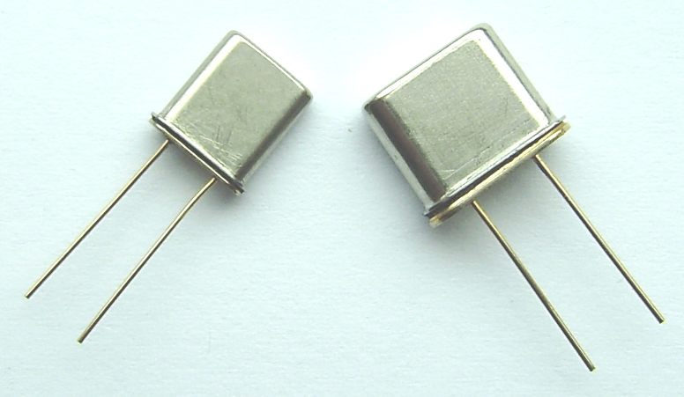
DRAWING
HX-RS-SMTP02
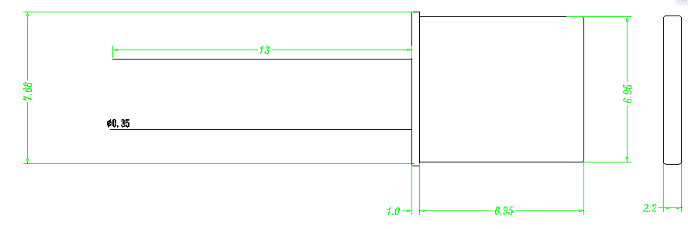

Product selection
Model |  |  | Code | Parameter | Note
HX-RS-SMTP02 |  |  | P | Pt100
Accuracy |  |  | A | Class A
 |  |  | B | Class B
Temperature range |  |  | 1 | -20～85℃
 |  |  | 2 | -50～150℃
 |  |  | 3 | -50～200℃
 |  |  | 4 | Customer designation
Lead | Structure |  | 2 | 2-Wire

